|  |  |
| --- | --- |
| Torre, Jephone Israel Jireh S.  BSCS 3-A | Sept 12, 2024 |
| **AppDevProject2** | |

1. Created my own repository.  
   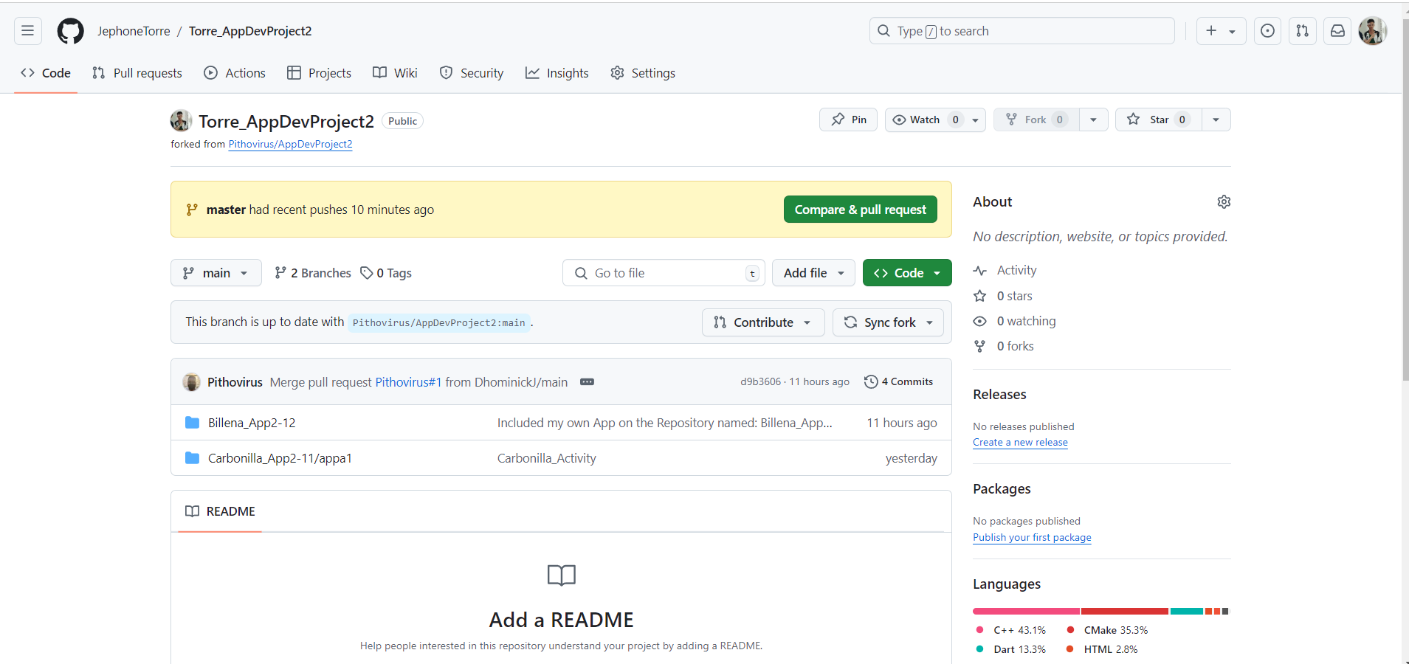
2. Git init to install the git then git add to add the files that I want to upload.

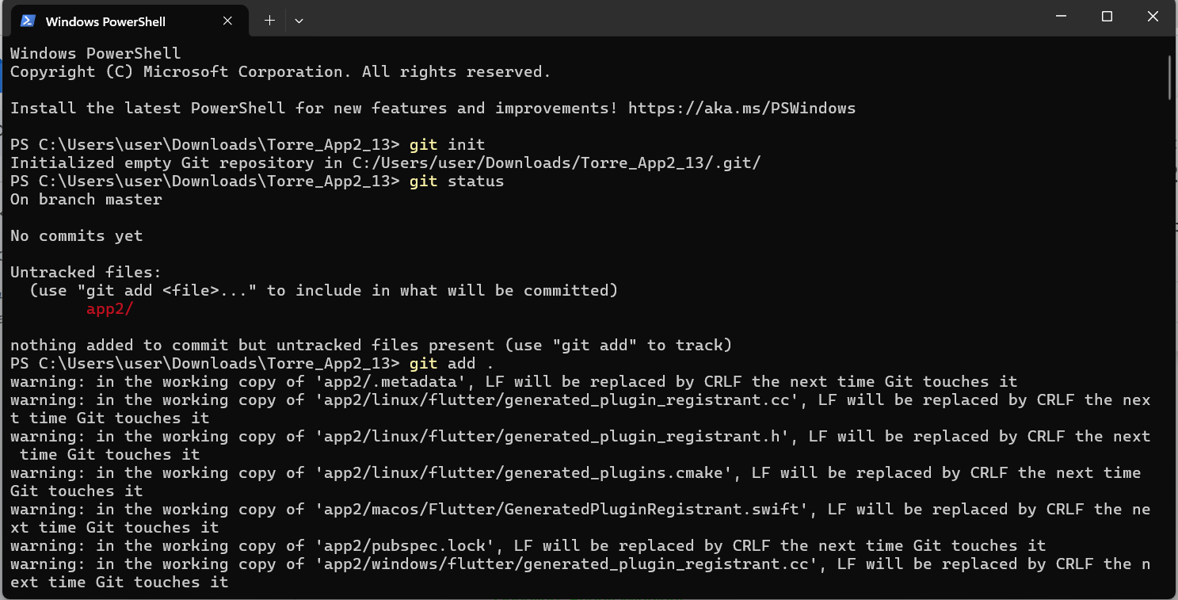

1. Git status to check the files are already there and ready to commit.

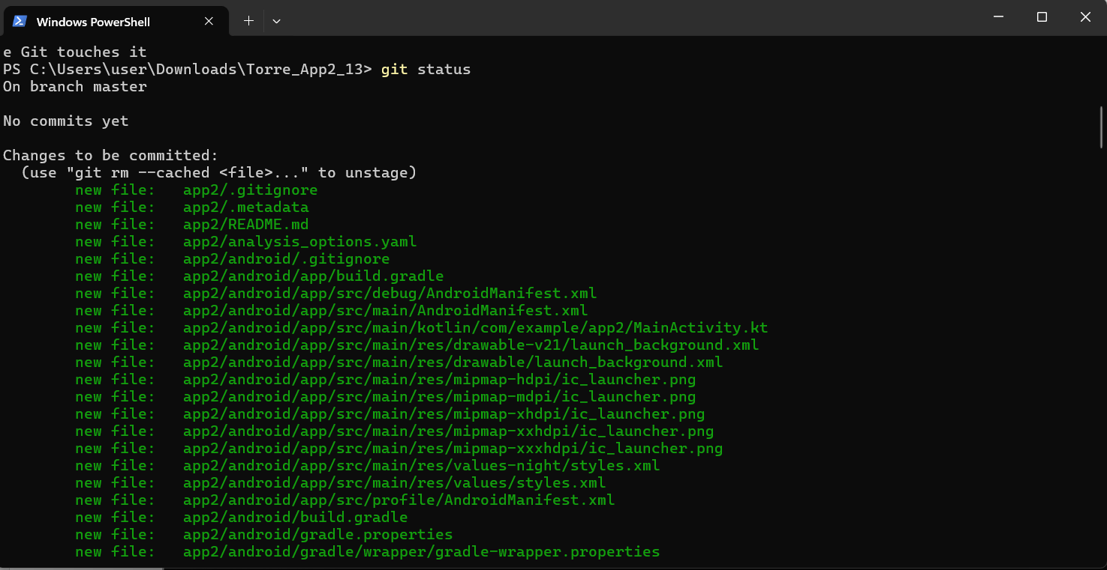

1. Git commit -m ”callendar app”. To commit the changes and the comment for easy identification of the files.

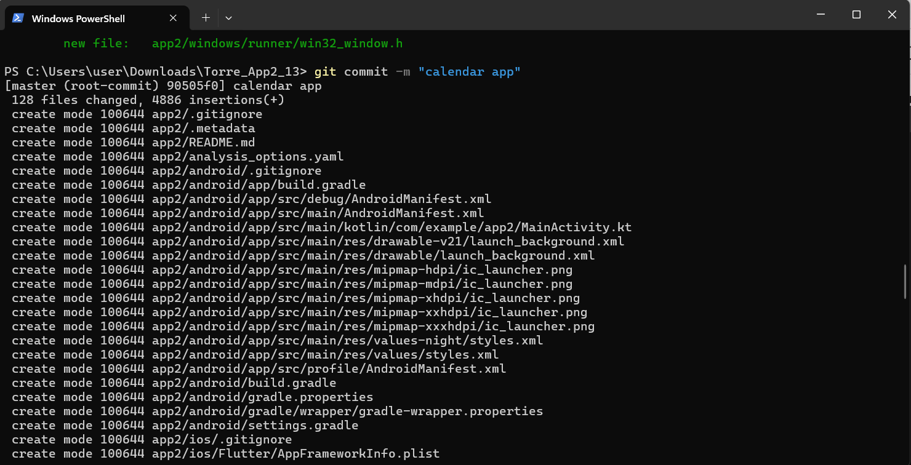

1. Git push -u -f origin master: to push the files in my repository or to the origin master so it can be ready for a pull request.

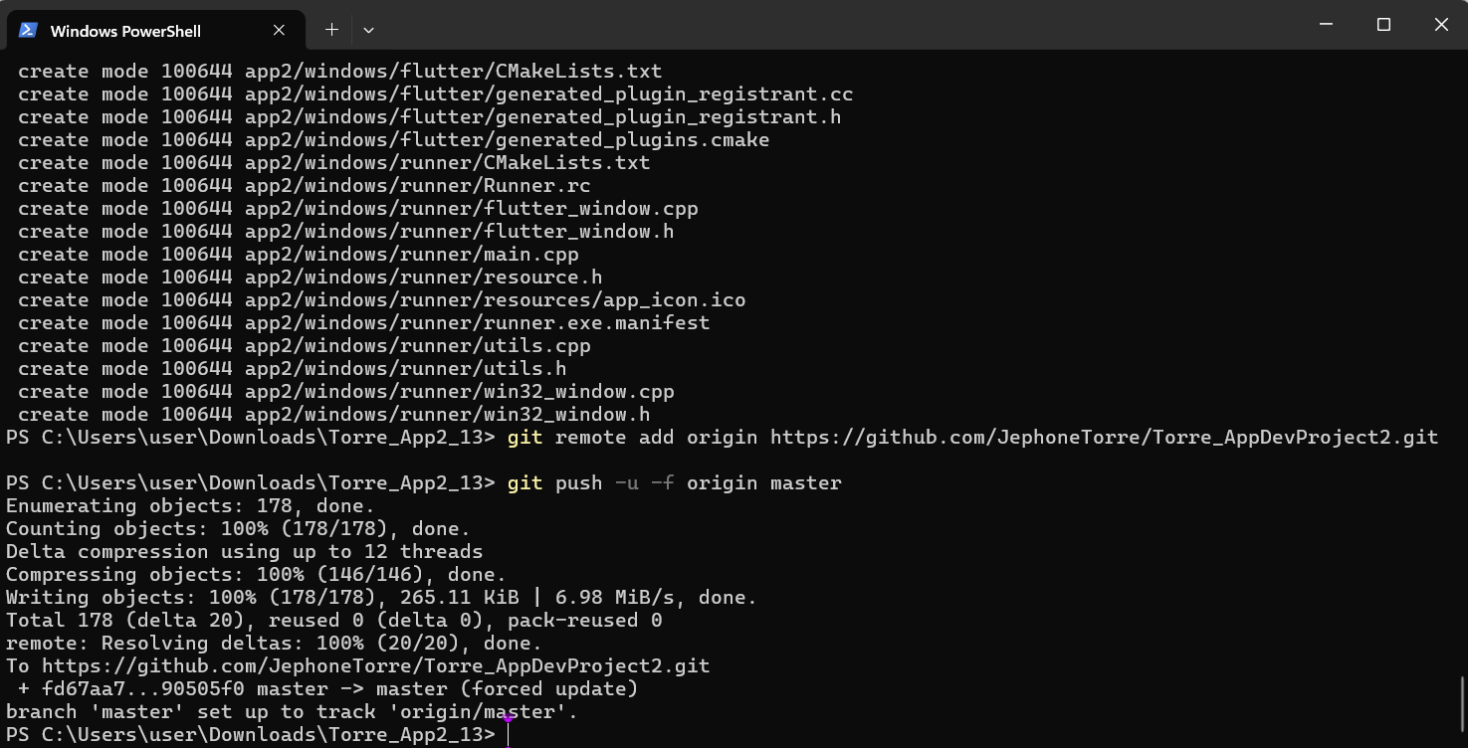

1. Pull Request

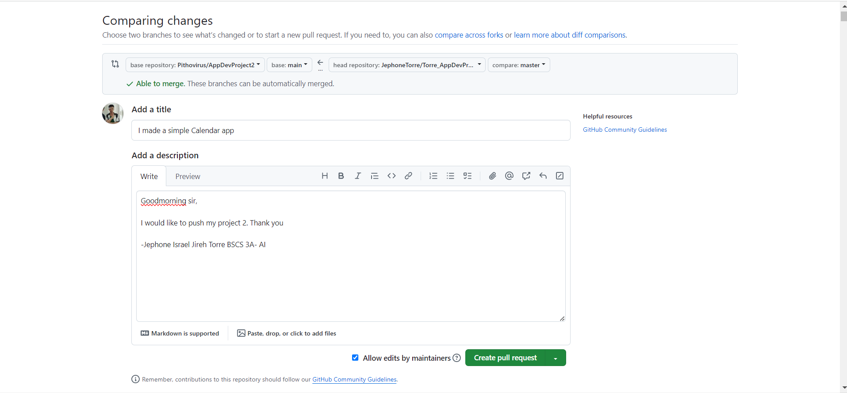

1. Outputs

